**Assignment – Apache Hue**

**DDL statements**

1. **Create**  
   create database abhilash_db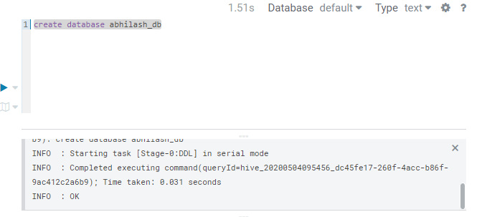Used to create new database in hive.
2. **Show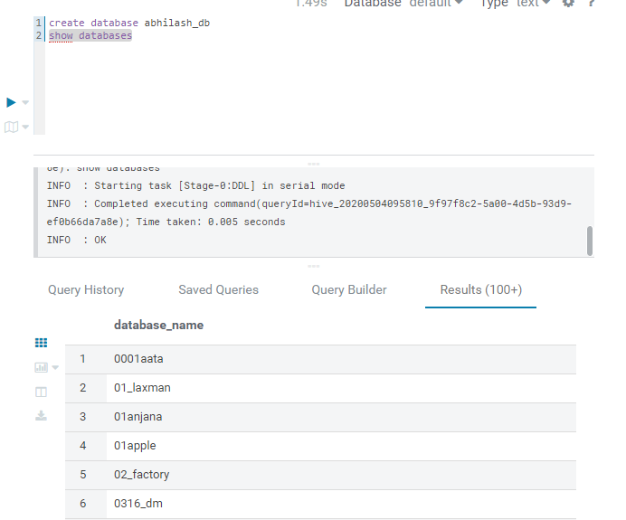 Used to show all databases in hive.**
3. **Use**

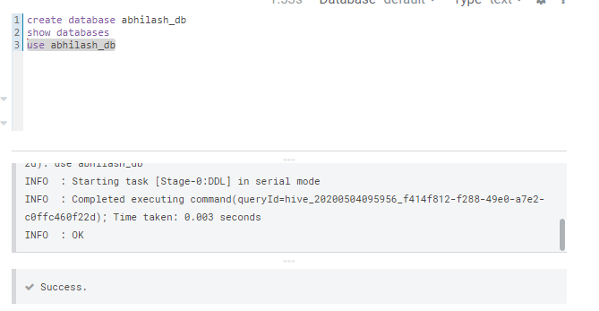

1. **Create table**

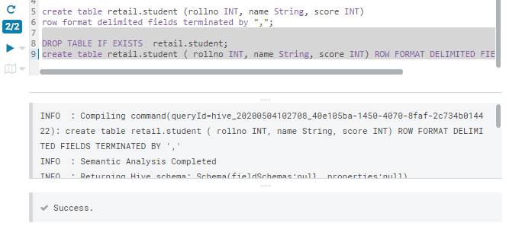Table already exists

1. **Drop Table**Table already existed so drop and create new.

**DML**

1. **Insert**

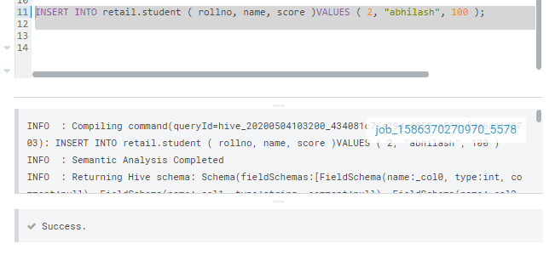

1. **Select**

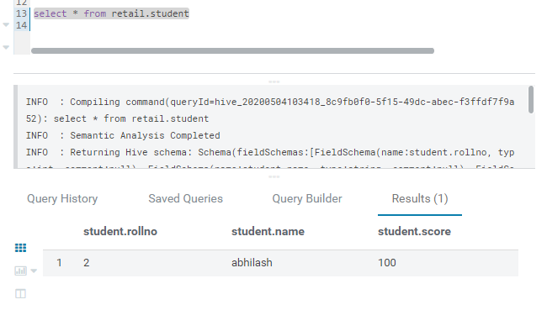

1. **Delete / Update**

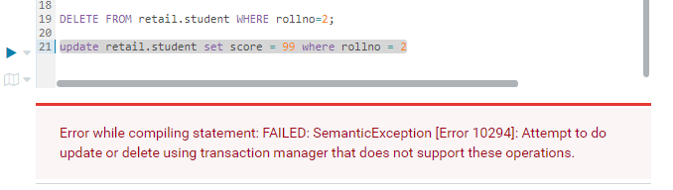Deleting or updating a record throws me an error

**4. Count**

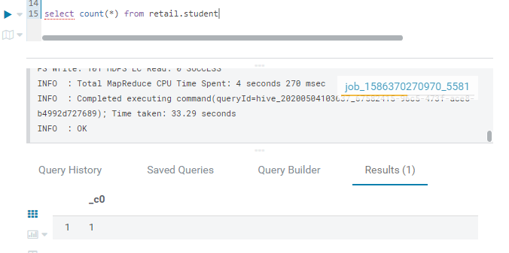

**5. Group By**

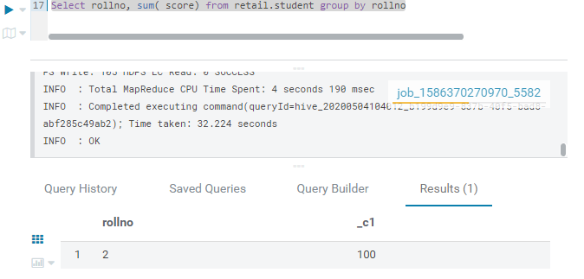

1. **Sum**

